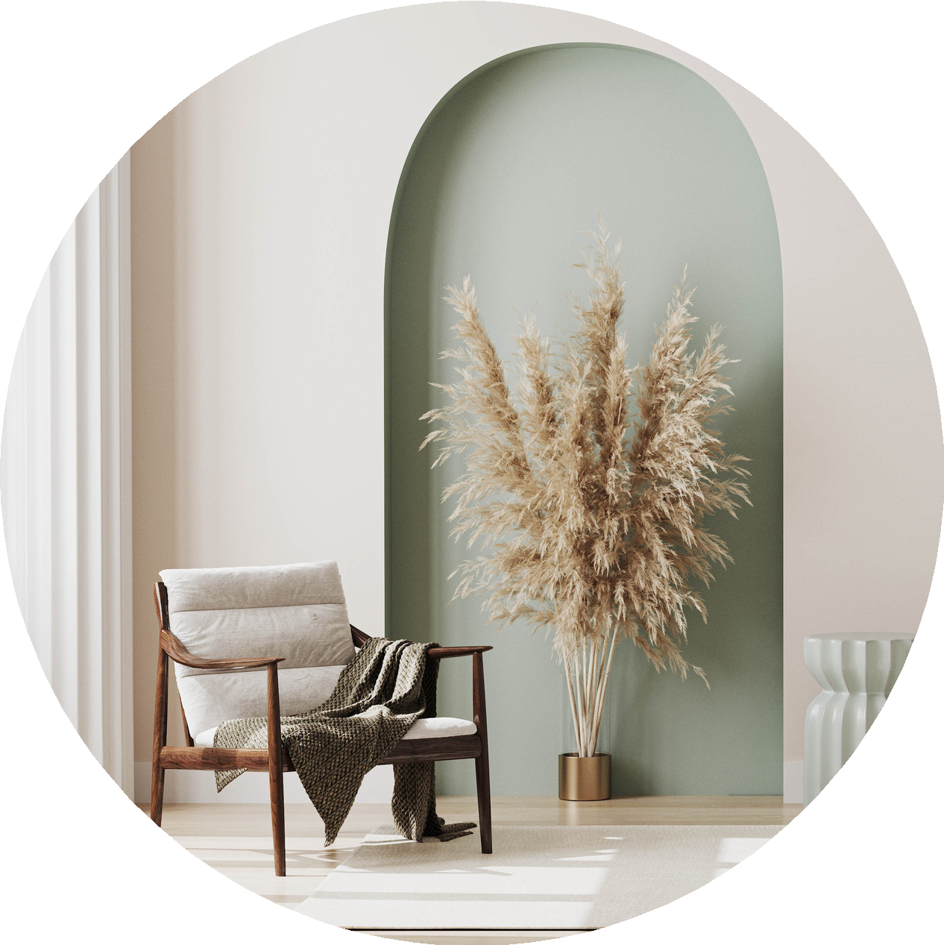
Build School By Eka buildschoolbyeka.com

The Ultimate
SCOPE SNEE/
A 30+ page room-by-room checklist designed for Indian homes covering every detail from electrical to wardrobe internals, kitchen fittings, automation, paint, plumbing, and more. The exact sheet we use in real luxury projects to ensure nothing is ever missed.

Scope of Work Page 1

Section A

Project Information


basic info
Project Address : Client Name(s): Property Type: □ Apartment □ Villa □ Farmhouse
Unit Type: □ 2BHK □ 3BHK □ 4BHK □ 5BHK
Total Carpet Area:


ceiling & height information

Notes:

Notes:
Date:

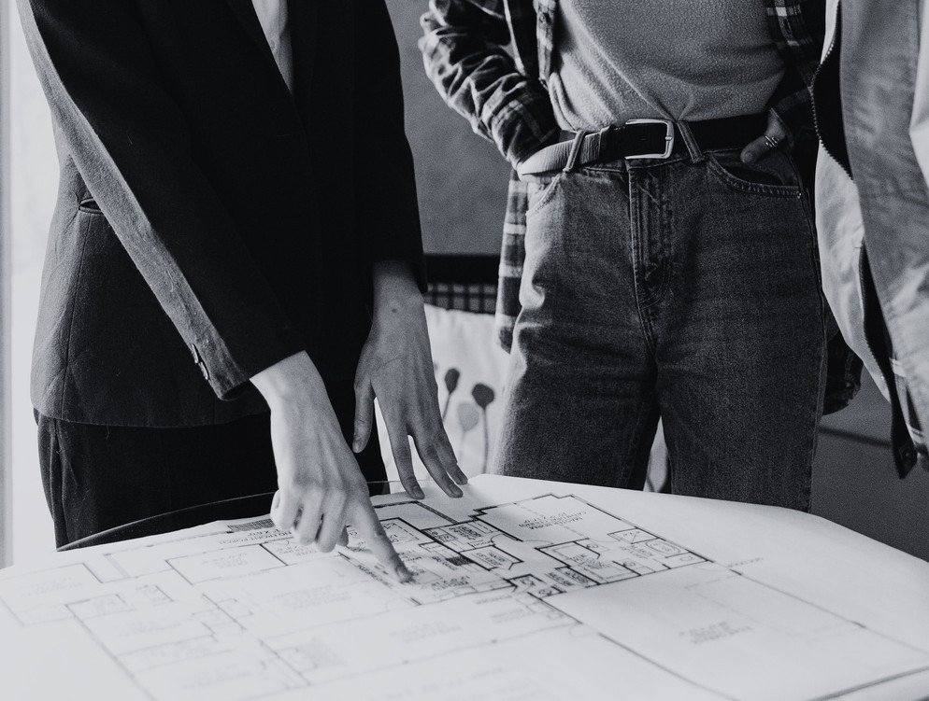

General Ceiling Height: Floor-to-Floor Height: Foyer Ceiling Height: Living Ceiling Height: Dining Ceiling Height: Kitchen Ceiling Height: Bedroom 1 Ceiling Height: Bedroom 2 Ceiling Height: Bedroom 3 Ceiling Height: Bedroom 4 Ceiling Height: Bedroom 5 Ceiling Height: Store Room Ceiling Height: Help Room Ceiling Height:


window information
Window Count (per room):
Sill Height Lintel Height
Window Type: □ Sliding □ Openable □ Fixed
Notes:

Page 2

buildschoolbyeka.com

Section B

Global Project Scope
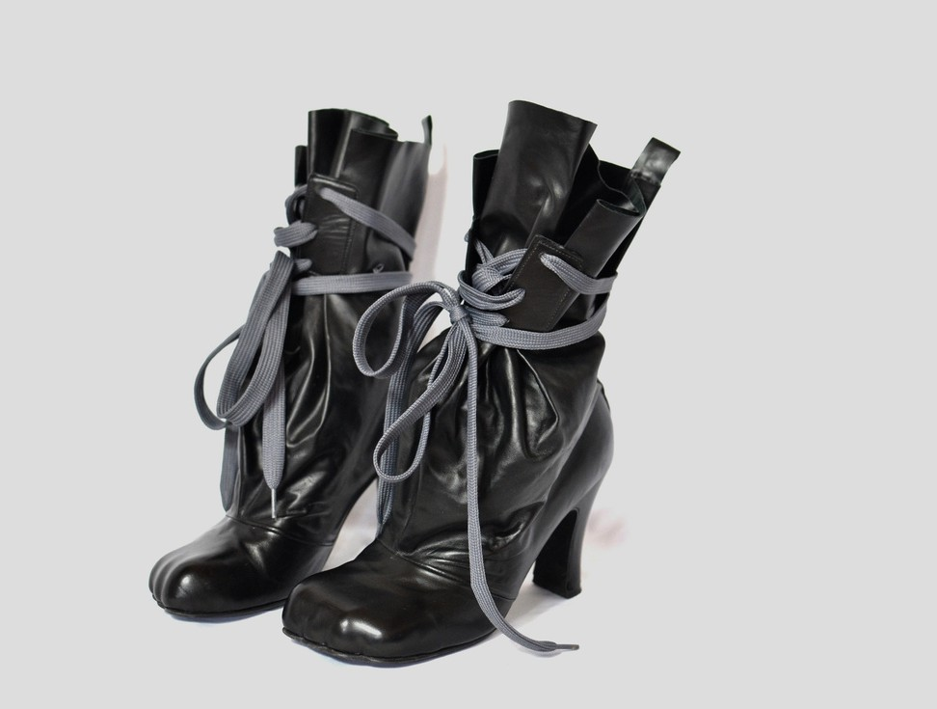

services required Notes:
- Full Home Renovation
- Interior Fit-Out
- Civil + Interior Turnkey
- Online Design Only
- Material Selection Support

- Project Management
- Furniture + Styling
- Vastu Consultation

Section C

Project Deliverables
Date:

- 2D Layouts
- Furniture Layout
- Electrical Layout

- Plumbing Layout
- Ceiling Layout
- Tile Layout
- Working Drawings
- 3D Renders
- Material Boards

- BOQ
- Site Visits
- Vendor Coordination
- Procurement Support
- Final Styling
- Photoshoot
Notes:

Page 3

buildschoolbyeka.com

Section D

Main Entrance



basic info
Length: Width:
Ceiling Height:

Notes:
Date:



door system & size
- Safety Door

- Main Wooden Door

- Two-Door System Width: Height:
Notes:

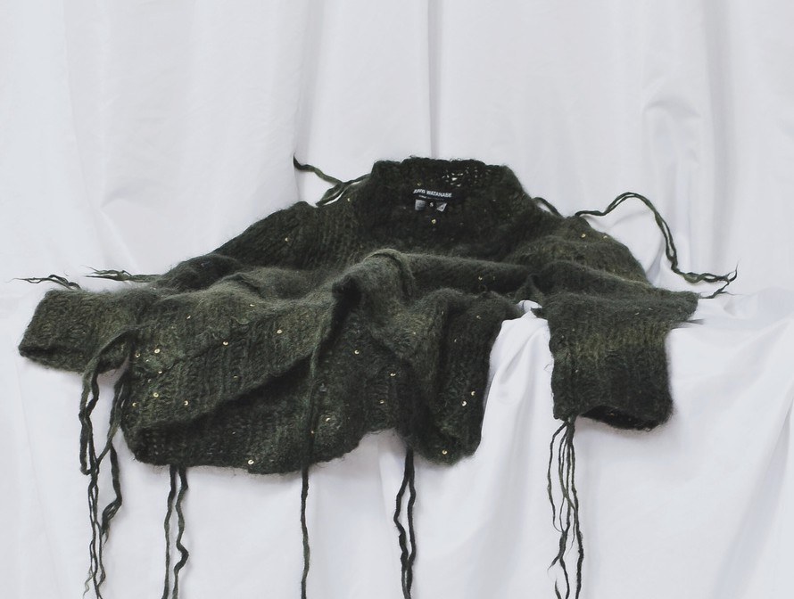
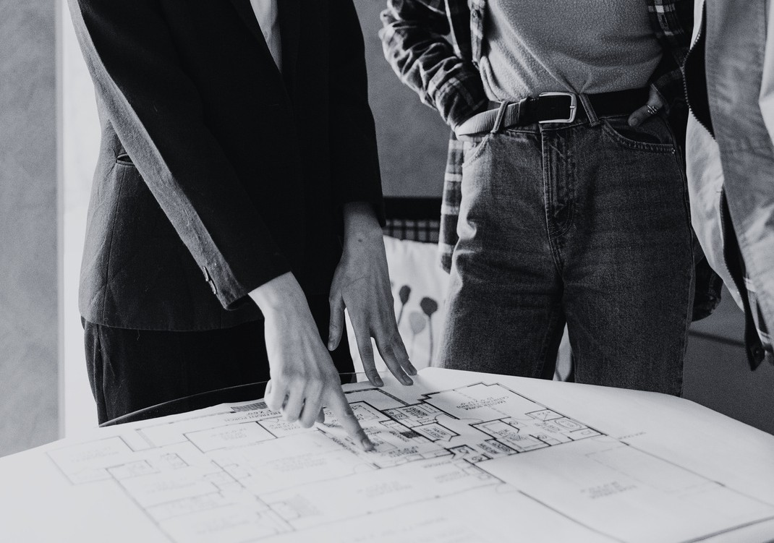
carpentry
- Shoe Rack

- Wall Panel - POP Design, Laminate , Veneer , Pu , Fabric , Glass , Duco, Acrylic , Stone

- Mirror

- Seating Near Shoerack

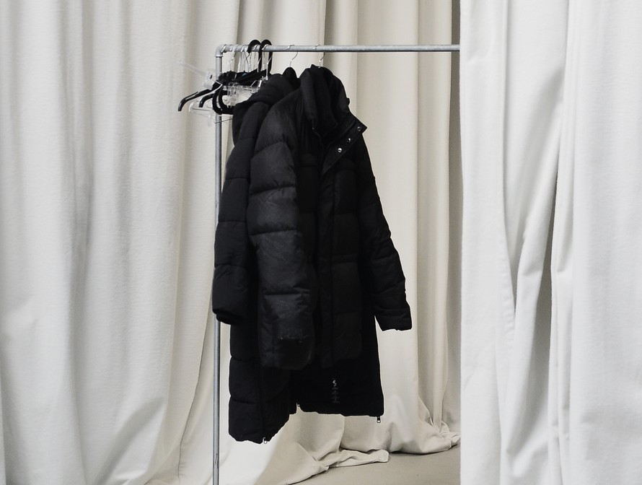

electrical
- Wall Light

- Ceiling Lights (no’s)

- Bell Wiring

- Staircase Light

Notes:

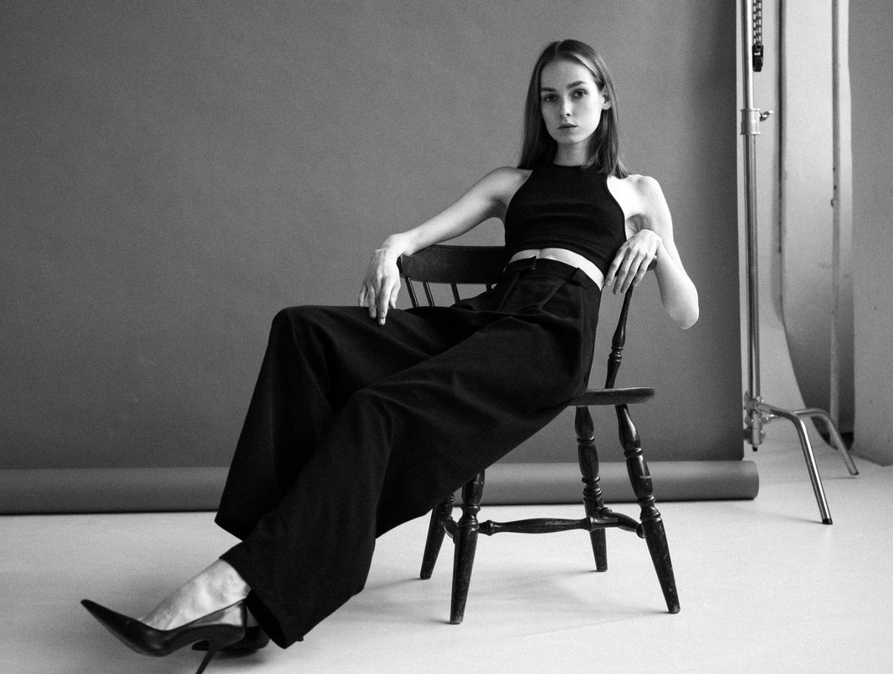

decor
- Planters

- Wall decor

- Rugs/Mats

- Entrance Flooring
Notes:

Page 4

buildschoolbyeka.com

Section E

Foyer Area


basic info Notes:
Length: Width:
Ceiling Height:
Date:



window info
Window Count (per room):
Sill Height Lintel Height
Window Type: □ Sliding □ Openable □ Fixed


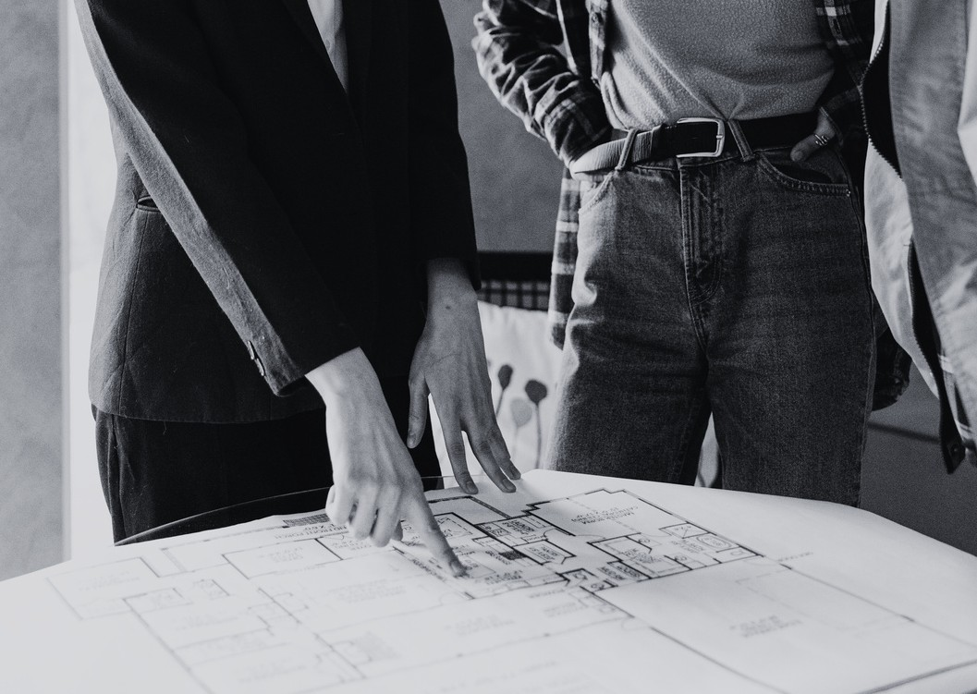
civil
- Demolition of flooring

- Demolition of walls

- New partitions / wall shifting

- Floor leveling / screeding



- New flooring installation

- Skirting installation

- Beam/column covering

- Window enlargement/reduction

- Door shifting / Door Enlargement / Add Extra Door
Notes:

Notes:



Page 5

buildschoolbyeka.com

Section E

Foyer Area



false ceiling

False Ceiling Required False Ceiling Type
- POP
- Wooden
- Stretch


- Grid

Cove Lighting Options
- Outside Cove Only
- Inside Cove Only
- Inside + Outside Cove

Ceiling Design Options

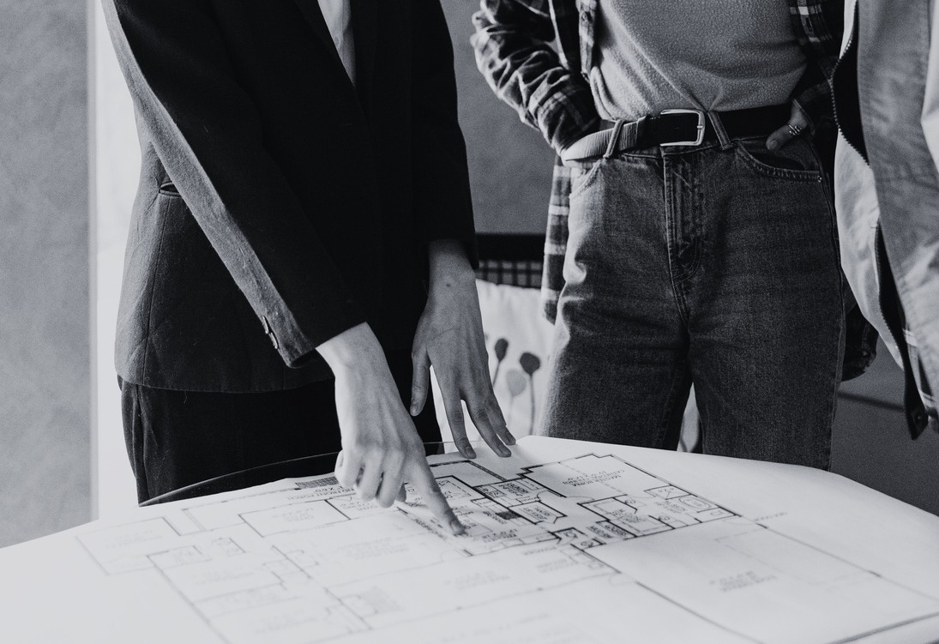
- Grooves
- Mouldings
- Beam Covering
- No Design

Notes:
Date:



carpentry

Console / Storage
- Console Table
- Shoe Storage
- Coat Hanger
- Mirror Unit



Hardware Levels
- Basic (Local Indian Brands)
- Mid (Hettich India / Ozone / Inox)
- Premium (Hafele / Hettich Germany)
- Ultra Premium (Blum Soft-Close)
Notes:

Page 6

buildschoolbyeka.com

Section E

Foyer Area



carpentry

Wall Panelling Options
- POP Design
- Laminate
- Veneer
- PU Coated


- Fabric Wrapped
- Glass
- Acrylic
- Stone Cladding Carpentry Material Ply/Hdhmr/mdf

Notes:
Date:



electrical

Wiring Brand
- Havells
- Polycab
- Finolex
- Local



Wire Safety Rating
- FR
- FRLS
- Non-FR

Switches


- Anchor Roma
- GM
- Legrand Myrius
- Schneider Norysis
- Premium Smart Switches

Page 7

buildschoolbyeka.com

Section E

Foyer Area



electrical

Lighting
- COB
- Downlights
- Panel Lights
- Profile Lights


- Cove Lights

Additional Electrical
- Wall Lights (Qty: )
- Console LED Strip
- Ac Wiring
- Speakers Required: Yes/No
- Automation Required: Yes/No


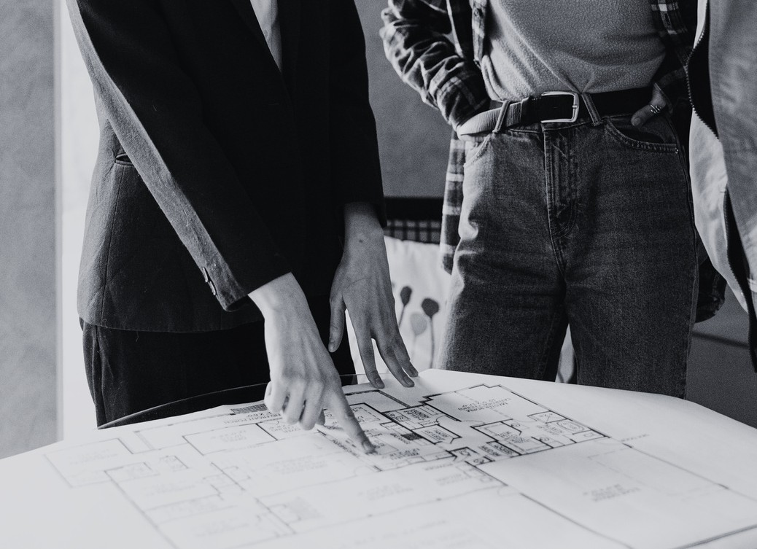
Automation Items
- Lights
- AC
- TV
- Speakers
Entrance bell



- Normal Bell

- Smart Bell (WiFi)

- Bell With Video Screen / Digital Door Camera Aircondition Types
- Drawing : Split / Cassette / Ductable



- Approx. Wiring Length :
paint
- Wall Paint Options: Royale Shine / PU / Texture / Royale Matt / Satin / Plastic Premium
- Ceiling Paint Options: Royale Shine / PU / Texture / Royale Matt / Satin / Plastic Premium

Notes:
Date:

Page 8

buildschoolbyeka.com

Section E

Foyer Area



soft furnishing
- Curtains: Sheer Only / Blackout Only / Sheer + Blackout
- Window Covering: Blinds / Curtains
Notes:



Section F

Notes:
Date:

Living / Drawing Room


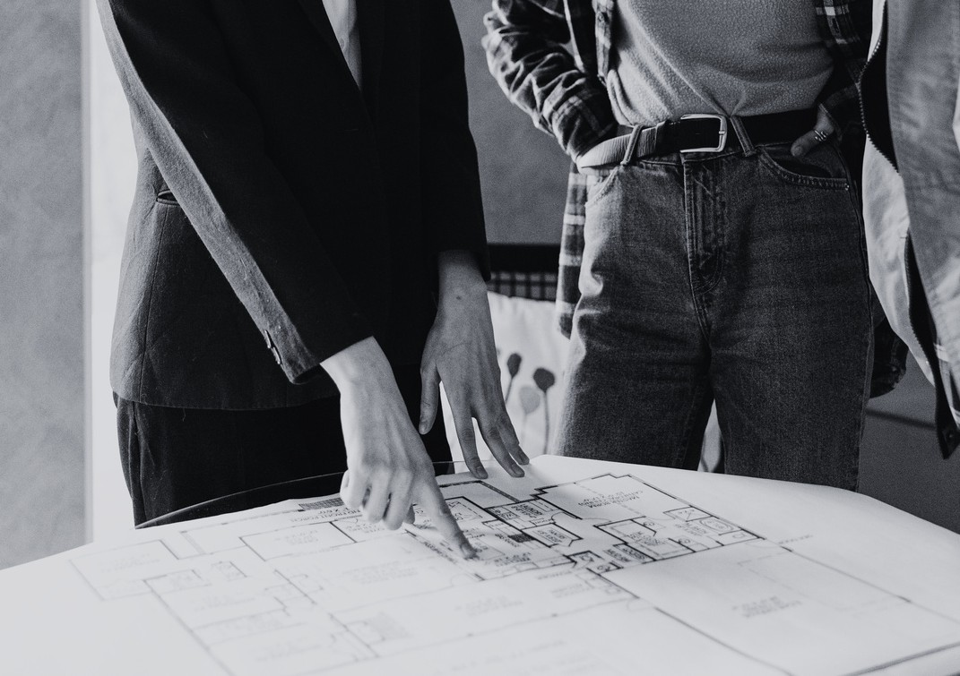
basic info
Length:
Width:


Ceiling Height: Window Count: Sill Height: Lintel Height: Balcony Access
- Yes □ No

Balcony Door
- Sliding
- Hinged Single


- Hinged Double
- Fixed
Size: Width Height
Balcony Railing
- Brick / Glass / Aluminium + Glass / Ss / Ms / Other
- Size : r.f.t/sq.ft

Page 9

buildschoolbyeka.com

Date:



civil & false ceiling
- Demolition of flooring
- Demolition of walls
- New partitions / wall shifting
- Floor leveling / screeding
- New flooring installation



- Skirting installation

- Beam/column covering

- Window enlargement/reduction

- Door shifting / Door Enlargement / Add Extra Door

False Ceiling Type
- POP


- Wooden
- Stretch
- Grid

Coves Ceiling Design
- Outside Only □ Grooves
- Inside Only □ Mouldings
- Inside + Outside □ Beam Hiding



floor covering
- Gloss Tile / Matt Tile
- Marble
- Granite



soft furnishings
- Curtains (Sheer / Blackout / Both)
- Blinds
- Rug
- Upholstery Requirements

Page 10

buildschoolbyeka.com

Date:



carpentry

Wall Panelling
  - Required
  - Number of Walls: 1 / 2 / 3
Notes:

  - Materials: POP / Laminate / Veneer / PU / MDF / Fabric / Glass / Acrylic / Stone
  - Wall Sizes : 1. 2. 3.



Furniture Units
  - TV Unit
  - Crockery Unit
  - Bar Unit
  - Console
  - Window Seating



Loose Furniture
  - Sofa: seater
  - Armchairs:
  - Lounge Chairs:
  - Coffee Table
  - Side Tables


  - Rug

Hardware Levels
  - Basic (Local Indian Brands)
  - Mid (Hettich India / Ozone / Inox)
  - Premium (Hafele / Hettich Germany)
  - Ultra Premium (Blum Soft-Close)



electrical
Wiring Brand
  - Havells □ Polycab □ Finolex □ Local
Wire Type
  - FR □ FRLS □ Non-FR

Page 11

buildschoolbyeka.com

Date:



electrical Notes:

Switches
  - Anchor □ GM □ Legrand □ Schneider □ Smart

Light Categories
  - COB
  - Downlights


  - Panel Lights
  - Profile Lights
  - Cove Lights

Other Electrical
  - Chandelier
  - Wall Lights (Qty )
  - Fans (Qty )


  - AC Wiring (Qty )
  - Speakers Required: Yes/No
  - Automation Required: Yes/No

Automation Items
  - Lights
  - Curtains
  - AC


  - TV
  - Speakers
  - Scene Settings

Aircondition Types
  - Drawing : Split / Cassette / Ductable
  - Approx. Wiring Length :



paint
  - Wall Paint Options: Royale Shine / PU / Texture / Royale Matt / Satin / Plastic Premium
  - Ceiling Paint Options: Royale Shine / PU / Texture / Royale Matt / Satin / Plastic Premium

Page 12

buildschoolbyeka.com

Section G

Dining Area



basic info
Length:
Width:


Ceiling Height: Window Count: Sill Height: Lintel Height: Balcony Access
  - Yes □ No

Balcony Door
  - Sliding
  - Hinged Single
  - Hinged Double


  - Fixed
Size: Width Height
Balcony Railing
  - Brick / Glass / Aluminium + Glass / Ss / Ms / Other
  - Size : r.f.t/sq.ft



civil
  - Demolition of flooring

  - Demolition of walls

  - New partitions / wall shifting

  - Floor leveling / screeding



  - New flooring installation

  - Skirting installation

  - Beam/column covering

  - Window enlargement/reduction

  - Door shifting / Door Enlargement / Add Extra Door

Notes:
Date:

Page 13

buildschoolbyeka.com

Section G

Dining Area



false ceiling

False Ceiling Required False Ceiling Type
  - POP
  - Wooden
  - Stretch


  - Grid

Cove Lighting Options
  - Outside Cove Only
  - Inside Cove Only
  - Inside + Outside Cove

Ceiling Design Options


  - Grooves
  - Mouldings
  - Beam Covering
  - No Design

Notes:
Date:



floor covering
  - Gloss Tile / Matt Tile
  - Marble
  - Granite



soft furnishings
  - Curtains (Sheer / Blackout / Both)
  - Blinds
  - Rug
  - Upholstery Requirements

Page 14

buildschoolbyeka.com

Section G

Dining Area



carpentry
Date:

Wall Panelling
  - Required
  - Number of Walls: 1 / 2 / 3


  - Materials: POP / Laminate / Veneer / PU / MDF / Fabric / Glass / Acrylic / Stone
  - Wall Sizes : 1. 2. 3.

Dining Storage
  - Crockery Unit
  - Console Table


  - Buffet / Sideboard

Furniture
  - Dining Table for persons
  - Chairs:
  - Bench Seating



Hardware Levels
  - Basic (Local Indian Brands)
  - Mid (Hettich India / Ozone / Inox)
  - Premium (Hafele / Hettich Germany)
  - Ultra Premium (Blum Soft-Close)



electrical
Wiring Brand
  - Havells □ Polycab □ Finolex □ Local
Wire Type
  - FR □ FRLS □ Non-FR

Page 15

buildschoolbyeka.com

Section G

Dining Area



electrical

Switches
  - Anchor □ GM □ Legrand □ Schneider □ Smart

Light Categories
  - COB
  - Downlights


  - Panel Lights
  - Profile Lights
  - Cove Lights

Other Electrical
  - Chandelier
  - Wall Lights (Qty )
  - Fans (Qty )


  - AC Wiring (Qty )
  - Speakers Required: Yes/No
  - Automation Required: Yes/No

Automation Items
  - Lights
  - Curtains


  - AC
  - TV
  - Speakers
  - Scene Settings

Aircondition Types
  - Drawing : Split / Cassette / Ductable
  - Approx. Wiring Length :



paint
  - Wall Paint Options: Royale Shine / PU / Texture / Royale Matt / Satin / Plastic Premium
  - Ceiling Paint Options: Royale Shine / PU / Texture / Royale Matt / Satin / Plastic Premium
Date:

Page 16

buildschoolbyeka.com

Section H

Kitchen



basic info
Length:
Width:


Ceiling Height: Window Count: Sill Height: Lintel Height: Balcony Access
  - Yes □ No

Balcony Door
  - Sliding
  - Hinged Single
  - Hinged Double


  - Fixed
Size: Width Height
Balcony Railing
  - Brick / Glass / Aluminium + Glass / Ss / Ms / Other
  - Size : r.f.t/sq.ft



civil
  - Demolition of flooring

  - Demolition of walls

  - New partitions / wall shifting

  - Floor leveling / screeding



  - New flooring installation

  - Skirting installation

  - Beam/column covering

  - Window enlargement/reduction

  - Door shifting / Door Enlargement / Add Extra Door

Notes:
Date:

Page 17

buildschoolbyeka.com

Section H

Kitchen



false ceiling

False Ceiling Required False Ceiling Type
  - POP
  - Wooden
  - Stretch


  - Grid

Cove Lighting Options
  - Outside Cove Only
  - Inside Cove Only
  - Inside + Outside Cove

Ceiling Design Options


  - Grooves
  - Mouldings
  - Beam Covering
  - No Design

Notes:
Date:



floor covering
  - Gloss Tile / Matt Tile
  - Marble
  - Granite



construction type
  - On-Site Carpenter
  - Carcass On-Site + Factory-Made Shutters
  - Full Modular Factory-Made Kitchen

Page 18

buildschoolbyeka.com

Section H

Kitchen
Date:



carpentry

Carcass Material
  - HDHMR
  - BWP Below Sink Only
  - BWP Entire Kitchen
  - Plywood (BWR/BWP)



Shutter Finish
  - Laminate
  - Acrylic
  - PU
  - Veneer
  - Glass

Hardware Level


  - Basic (Local)
  - Mid (Hettich India / Ozone / Inox)
  - Premium (Hafele / Hettich Germany)
  - Ultra Premium (Blum)

Fittings
  - Corner Unit (qty )


  - Tandem Drawers (qty )
  - Bottle Pullout (qty )
  - Pantry Unit
  - Rolling Shutter
  - Cutlery Tray
  - Grain Trolley
  - Wicker Basket


  - Integrated Dustbin
  - Glass Tray Plate Tray

Counter
  - Granite
  - Quartz
  - Marble
  - Backsplash Material:
Notes:

Page 19

buildschoolbyeka.com

Section H

Kitchen



electrical

Switches
  - Anchor □ GM □ Legrand □ Schneider □ Smart

Light Categories
  - COB
  - Panel Lights


  - Profile Lights
  - Cove Lights

Other Electrical
  - Fans (Qty )
  - AC Wiring (Qty )
  - Speakers Required: Yes/No

Aircondition Types


  - Kitchen : Split / Cassette / Ductable
  - Approx. Wiring Length :

Heavy Appliances
  - Hob Point
  - Chimney + Duct Route
  - Microwave


  - Oven
  - Refrigerator
  - Dishwasher Electrical Point
  - Exhaust
  - Aquaguard/RO

Wiring Brand
  - Havells □ Polycab □ Finolex □ Local



Wire Safety
  - FR □ FRLS □ Non-FR

Lights
  - Under-Cabinet LED
  - Ceiling Lights
  - Profile Lights
Date:

Page 20

buildschoolbyeka.com

Section H

Kitchen
Date:



paint
  - Ceiling Paint Options: Royale Shine / PU / Texture / Royale Matt / Satin / Plastic Premium



plumbing
  - Sink Relocation
  - Drain Line Change
  - Dishwasher Plumbing
  - Geyser Required: Yes/No
  - RO Location: Under-Sink / Over-Head
  - Plumbing Material Brand: Astral / Supreme / Prakash / Ashirvad



notes






Page 21

buildschoolbyeka.com

Section I

Bedroom 1 & Washroom 1
Date:



basic info
Length:
Width:


Ceiling Height: Window Count: Sill Height: Lintel Height: Balcony Access
  - Yes □ No

Balcony Door
  - Sliding
  - Hinged Single
  - Hinged Double


  - Fixed
Size: Width Height
Balcony Railing
  - Brick / Glass / Aluminium + Glass / Ss / Ms / Other
  - Size : r.f.t/sq.ft



civil
  - Demolition of flooring

  - Demolition of walls

  - New partitions / wall shifting

  - Floor leveling / screeding



  - New flooring installation

  - Skirting installation

  - Beam/column covering

  - Window enlargement/reduction

  - Door shifting / Door Enlargement / Add Extra Door
Notes:

Page 22

buildschoolbyeka.com

Section I

Bedroom 1 & Washroom 1



false ceiling

False Ceiling Required False Ceiling Type
  - POP
  - Wooden
  - Stretch


  - Grid

Cove Lighting Options
  - Outside Cove Only
  - Inside Cove Only
  - Inside + Outside Cove

Ceiling Design Options


  - Grooves
  - Mouldings
  - Beam Covering
  - No Design

Notes:
Date:



floor covering
  - Gloss Tile / Matt Tile
  - Marble
  - Granite



soft furnishings
  - Curtains (Sheer / Blackout / Both)
  - Blinds
  - Rug
  - Upholstery Requirements

Page 23

buildschoolbyeka.com

Section I

Bedroom 1 & Washroom 1



carpentry
Date:

Wall Panelling
  - Required
  - Number of Walls: 1 / 2 / 3


  - Materials: POP / Laminate / Veneer / PU / MDF / Fabric / Glass / Acrylic / Stone
  - Wall Sizes : 1. 2. 3.

Wardrobe Type
  - Normal Wardrobe
  - Walk-In Wardrobe

Wardrobe Height


  - Full Height
  - 8 ft
  - 8 ft + Loft Dimensions Width Depth


Loft Height

Internal Layout
  - Hanging Rod
  - Hanging Pullout
  - Shelves (qty )
  - Drawers (qty )
  - Shoe Rack


  - Trouser Pullout
  - Tie Rack
  - Jewellery Tray
  - Mirror Inside
  - Sensor Light

Page 24

buildschoolbyeka.com

Section I

Bedroom 1 & Washroom 1



carpentry
Date:

Shutter Finish
  - Laminate
  - Veneer
  - PU


  - Acrylic
  - Glass

Hardware Levels
  - Basic
  - Mid
  - Premium


  - Ultra Premium

Other Carpentry
  - Bed: Single Box / Double Box
  - Headboard
  - Footboard
  - Side Tables


  - Study Table
  - Dressing Table
  - TV Panel
  - Bookshelf

Loose furniture
  - Chair


  - Ottoman
  - Sofa
  - Bench

Page 25

buildschoolbyeka.com

Section I

Bedroom 1 & Washroom 1



electrical

Switches
  - Anchor □ GM □ Legrand □ Schneider □ Smart

Light Categories
  - COB
  - Downlights


  - Panel Lights
  - Profile Lights
  - Cove Lights

Other Electrical
  - Chandelier
  - Wall Lights (Qty )
  - Fans (Qty )


  - AC Wiring (Qty )
  - Speakers Required: Yes/No
  - Automation Required: Yes/No

Automation Items
  - Lights
  - Curtains


  - AC
  - TV
  - Speakers
  - Scene Settings

Aircondition Types
  - Drawing : Split / Cassette / Ductable
  - Approx. Wiring Length :



paint
  - Wall Paint Options: Royale Shine / PU / Texture / Royale Matt / Satin / Plastic Premium
  - Ceiling Paint Options: Royale Shine / PU / Texture / Royale Matt / Satin / Plastic Premium
Date:

Page 26

buildschoolbyeka.com

Section I

Bedroom 1 & Washroom 1



washroom 1

Basic
Length | Width | Ceiling Height
Window Count | Sill | Lintel
Date:

Civil


  - Waterproofing
  - Replace Fittings Only
  - Full Demolition
  - Drain Pipe Change
  - Supply Pipe Change

Wall Coverings


  - Tile
  - Marble
  - Granite
  - Feature Tile
Grout Color:



Floor Coverings
  - Anti-Skid Tile
  - Marble
  - Granite
Grout Color:

Basin Type


  - Over-Counter
  - Under-Counter
  - Table-Top
  - Integrated
  - Wall-Mounted

Page 27

buildschoolbyeka.com

Section I

Bedroom 1 & Washroom 1



washroom 1

Shower Type
  - Wall-Mounted
  - Ceiling-Mounted
  - Shower Panel
  - Body Jets



Fitting Brands
  - Cera
  - Hindware
  - Jaquar
  - Kohler
  - Grohe


  - Hansgrohe
  - Other
Date:

Plumbing Material
  - Astral
  - Supreme
  - Prakash


  - Ashirvad

Electrical
  - Mirror Light
  - Ceiling Light
  - Exhaust Fan


  - Geyser
Wiring Brand: Havells / Polycab / Finolex / Local
Wire Type: FR / FRLS / Non-FR
Switch Type: Anchor / GM / Legrand / Schneider / Smart

PAINT
  - Ceiling Paint
Page 28

buildschoolbyeka.com

Section J

Bedroom 2 & Washroom 2
Date:



basic info
Length:
Width:


Ceiling Height: Window Count: Sill Height: Lintel Height: Balcony Access
  - Yes □ No

Balcony Door
  - Sliding
  - Hinged Single
  - Hinged Double


  - Fixed
Size: Width Height
Balcony Railing
  - Brick / Glass / Aluminium + Glass / Ss / Ms / Other
  - Size : r.f.t/sq.ft



civil
  - Demolition of flooring

  - Demolition of walls

  - New partitions / wall shifting

  - Floor leveling / screeding



  - New flooring installation

  - Skirting installation

  - Beam/column covering

  - Window enlargement/reduction

  - Door shifting / Door Enlargement / Add Extra Door
Notes:

Page 29

buildschoolbyeka.com

Section J

Bedroom 2 & Washroom 2



false ceiling

False Ceiling Required False Ceiling Type
  - POP
  - Wooden
  - Stretch


  - Grid

Cove Lighting Options
  - Outside Cove Only
  - Inside Cove Only
  - Inside + Outside Cove

Ceiling Design Options


  - Grooves
  - Mouldings
  - Beam Covering
  - No Design

Notes:
Date:



floor covering
  - Gloss Tile / Matt Tile
  - Marble
  - Granite



soft furnishings
  - Curtains (Sheer / Blackout / Both)
  - Blinds
  - Rug
  - Upholstery Requirements

Page 30

buildschoolbyeka.com

Section J

Bedroom 2 & Washroom 2



carpentry
Date:

Wall Panelling
  - Required
  - Number of Walls: 1 / 2 / 3


  - Materials: POP / Laminate / Veneer / PU / MDF / Fabric / Glass / Acrylic / Stone
  - Wall Sizes : 1. 2. 3.

Wardrobe Type
  - Normal Wardrobe
  - Walk-In Wardrobe

Wardrobe Height


  - Full Height
  - 8 ft
  - 8 ft + Loft Dimensions Width Depth


Loft Height

Internal Layout
  - Hanging Rod
  - Hanging Pullout
  - Shelves (qty )
  - Drawers (qty )
  - Shoe Rack


  - Trouser Pullout
  - Tie Rack
  - Jewellery Tray
  - Mirror Inside
  - Sensor Light

Page 31

buildschoolbyeka.com

Section J

Bedroom 2 & Washroom 2



carpentry
Date:

Shutter Finish
  - Laminate
  - Veneer
  - PU


  - Acrylic
  - Glass

Hardware Levels
  - Basic
  - Mid
  - Premium


  - Ultra Premium

Other Carpentry
  - Bed: Single Box / Double Box
  - Headboard
  - Footboard
  - Side Tables


  - Study Table
  - Dressing Table
  - TV Panel
  - Bookshelf

Loose furniture
  - Chair


  - Ottoman
  - Sofa
  - Bench

Page 32

buildschoolbyeka.com

Section J

Bedroom 2 & Washroom 2



electrical

Switches
  - Anchor □ GM □ Legrand □ Schneider □ Smart

Light Categories
  - COB
  - Downlights


  - Panel Lights
  - Profile Lights
  - Cove Lights

Other Electrical
  - Chandelier
  - Wall Lights (Qty )
  - Fans (Qty )


  - AC Wiring (Qty )
  - Speakers Required: Yes/No
  - Automation Required: Yes/No

Automation Items
  - Lights
  - Curtains


  - AC
  - TV
  - Speakers
  - Scene Settings

Aircondition Types
  - Drawing : Split / Cassette / Ductable
  - Approx. Wiring Length :



paint
  - Wall Paint Options: Royale Shine / PU / Texture / Royale Matt / Satin / Plastic Premium
  - Ceiling Paint Options: Royale Shine / PU / Texture / Royale Matt / Satin / Plastic Premium
Date:

Page 33

buildschoolbyeka.com

Section J

Bedroom 2 & Washroom 2



washroom 2

Basic
Length | Width | Ceiling Height
Window Count | Sill | Lintel
Date:

Civil


  - Waterproofing
  - Replace Fittings Only
  - Full Demolition
  - Drain Pipe Change
  - Supply Pipe Change

Wall Coverings


  - Tile
  - Marble
  - Granite
  - Feature Tile
Grout Color:



Floor Coverings
  - Anti-Skid Tile
  - Marble
  - Granite
Grout Color:

Basin Type


  - Over-Counter
  - Under-Counter
  - Table-Top
  - Integrated
  - Wall-Mounted

Page 34

buildschoolbyeka.com

Section J

Bedroom 2 & Washroom 2



washroom 2

Shower Type
  - Wall-Mounted
  - Ceiling-Mounted
  - Shower Panel
  - Body Jets



Fitting Brands
  - Cera
  - Hindware
  - Jaquar
  - Kohler
  - Grohe


  - Hansgrohe
  - Other
Date:

Plumbing Material
  - Astral
  - Supreme
  - Prakash


  - Ashirvad

Electrical
  - Mirror Light
  - Ceiling Light
  - Exhaust Fan


  - Geyser
Wiring Brand: Havells / Polycab / Finolex / Local
Wire Type: FR / FRLS / Non-FR
Switch Type: Anchor / GM / Legrand / Schneider / Smart

PAINT
  - Ceiling Paint
Page 35

buildschoolbyeka.com

Section K

Bedroom 3 & Washroom 3
Date:



basic info
Length:
Width:


Ceiling Height: Window Count: Sill Height: Lintel Height: Balcony Access
  - Yes □ No

Balcony Door
  - Sliding
  - Hinged Single
  - Hinged Double


  - Fixed
Size: Width Height
Balcony Railing
  - Brick / Glass / Aluminium + Glass / Ss / Ms / Other
  - Size : r.f.t/sq.ft



civil
  - Demolition of flooring

  - Demolition of walls

  - New partitions / wall shifting

  - Floor leveling / screeding



  - New flooring installation

  - Skirting installation

  - Beam/column covering

  - Window enlargement/reduction

  - Door shifting / Door Enlargement / Add Extra Door
Notes:

Page 36

buildschoolbyeka.com

Section K

Bedroom 3 & Washroom 3



false ceiling

False Ceiling Required False Ceiling Type
  - POP
  - Wooden
  - Stretch


  - Grid

Cove Lighting Options
  - Outside Cove Only
  - Inside Cove Only
  - Inside + Outside Cove

Ceiling Design Options


  - Grooves
  - Mouldings
  - Beam Covering
  - No Design

Notes:
Date:



floor covering
  - Gloss Tile / Matt Tile
  - Marble
  - Granite



soft furnishings
  - Curtains (Sheer / Blackout / Both)
  - Blinds
  - Rug
  - Upholstery Requirements

Page 37

buildschoolbyeka.com

Section K

Bedroom 3 & Washroom 3



carpentry
Date:

Wall Panelling
  - Required
  - Number of Walls: 1 / 2 / 3


  - Materials: POP / Laminate / Veneer / PU / MDF / Fabric / Glass / Acrylic / Stone
  - Wall Sizes : 1. 2. 3.

Wardrobe Type
  - Normal Wardrobe
  - Walk-In Wardrobe

Wardrobe Height


  - Full Height
  - 8 ft
  - 8 ft + Loft Dimensions Width Depth


Loft Height

Internal Layout
  - Hanging Rod
  - Hanging Pullout
  - Shelves (qty )
  - Drawers (qty )
  - Shoe Rack


  - Trouser Pullout
  - Tie Rack
  - Jewellery Tray
  - Mirror Inside
  - Sensor Light

Page 38

buildschoolbyeka.com

Section K

Bedroom 3 & Washroom 3



carpentry
Date:

Shutter Finish
  - Laminate
  - Veneer
  - PU


  - Acrylic
  - Glass

Hardware Levels
  - Basic
  - Mid
  - Premium


  - Ultra Premium

Other Carpentry
  - Bed: Single Box / Double Box
  - Headboard
  - Footboard
  - Side Tables


  - Study Table
  - Dressing Table
  - TV Panel
  - Bookshelf

Loose furniture
  - Chair


  - Ottoman
  - Sofa
  - Bench

Page 39

buildschoolbyeka.com

Section K

Bedroom 3 & Washroom 3



electrical

Switches
  - Anchor □ GM □ Legrand □ Schneider □ Smart

Light Categories
  - COB
  - Downlights


  - Panel Lights
  - Profile Lights
  - Cove Lights

Other Electrical
  - Chandelier
  - Wall Lights (Qty )
  - Fans (Qty )


  - AC Wiring (Qty )
  - Speakers Required: Yes/No
  - Automation Required: Yes/No

Automation Items
  - Lights
  - Curtains


  - AC
  - TV
  - Speakers
  - Scene Settings

Aircondition Types
  - Drawing : Split / Cassette / Ductable
  - Approx. Wiring Length :



paint
  - Wall Paint Options: Royale Shine / PU / Texture / Royale Matt / Satin / Plastic Premium
  - Ceiling Paint Options: Royale Shine / PU / Texture / Royale Matt / Satin / Plastic Premium
Date:

Page 40

buildschoolbyeka.com

Section K

Bedroom 3 & Washroom 3



washroom 3

Basic
Length | Width | Ceiling Height
Window Count | Sill | Lintel
Date:

Civil


  - Waterproofing
  - Replace Fittings Only
  - Full Demolition
  - Drain Pipe Change
  - Supply Pipe Change

Wall Coverings


  - Tile
  - Marble
  - Granite
  - Feature Tile
Grout Color:



Floor Coverings
  - Anti-Skid Tile
  - Marble
  - Granite
Grout Color:

Basin Type


  - Over-Counter
  - Under-Counter
  - Table-Top
  - Integrated
  - Wall-Mounted

Page 41

buildschoolbyeka.com

Section K

Bedroom 3 & Washroom 3



washroom 3

Shower Type
  - Wall-Mounted
  - Ceiling-Mounted
  - Shower Panel
  - Body Jets



Fitting Brands
  - Cera
  - Hindware
  - Jaquar
  - Kohler
  - Grohe


  - Hansgrohe
  - Other
Date:

Plumbing Material
  - Astral
  - Supreme
  - Prakash


  - Ashirvad

Electrical
  - Mirror Light
  - Ceiling Light
  - Exhaust Fan


  - Geyser
Wiring Brand: Havells / Polycab / Finolex / Local
Wire Type: FR / FRLS / Non-FR
Switch Type: Anchor / GM / Legrand / Schneider / Smart

PAINT
  - Ceiling Paint
Page 42

buildschoolbyeka.com

Section L

Domestic Help Room



basic info
Length/Width/Height Wardrobe dimensions Material


Finish Hardware level Bed niche

Electrical:


Wiring brand Wire type Switches Paint Ventilation Fan
Lights



Help Bathroom Tiles/wall covering Floor covering WC
Basin Fittings
Plumbing line material Exhaust


Switches Geyser Paint
Notes:

Notes:
Date:

Page 43

buildschoolbyeka.com

Section M

Store Room



basic info
Length | Width | Ceiling Height

Notes:
Date:

Store Wardrobe

Width (ft):


Height (ft):
Material: Laminate / Veneer / PU / Acrylic Carcass: HDHMR / BWP / Ply
Hardware Level: Basic / Mid / Premium / Ultra Premium Lofts


Shelves Lighting Ventilation

Paint (Walls + Ceiling)
Electrical (same wiring + switches + lights)

Notes:





Page 44

buildschoolbyeka.com

Section N

Balconies



balcony template

Basic
Length | Width | Ceiling Height
Door Type: □ Sliding □ Hinged Single □ Hinged Double Door/Window Size (W x H):
Railing Type: □ Glass □ MS □ SS □ Brick □ Other


Railing Height:

Notes:
Date:

Civil
  - Waterproofing Required
  - Slope Correction
  - PCC / Leveling
  - Tile Removal


  - Wall Plaster Repair
  - Ceiling Repair / Waterproofing
  - Drain Cleaning / New Drain

Floor Coverings
  - Anti-Skid Tile


  - Stone
  - Granite
  - Wooden Tile
  - Concrete Texture Tile/Stone Size: Grout Color:



Wall Coverings
  - Exterior Paint
  - Texture Paint
  - Stone Cladding
  - Tile Cladding
  - Brick Cladding
  - Feature Wall (Material: )
Page 45

buildschoolbyeka.com

Section N

Balconies



balcony template

Ceiling
  - Exterior Paint
  - Cement Sheet Ceiling
  - Wooden Slats
  - Metal / UPVC Ceiling


  - Waterproof Coat Required Lighting: □ Yes □ No
Fan Point: □ Yes □ No

Notes:
Date:

Carpentry / Built-In Elements
  - Seating Bench
Material: □ Stone □ Wood □ WPC □ Composite


  - Storage Unit
Material: □ Laminate □ PU □ Veneer □ Exterior Ply □ WPC
  - Outdoor Cabinet
  - Planter Box (Built-In)
  - Privacy Screen / Jaali
Material: □ Metal □ WPC □ Cement □ Wood □ Other



Loose Furniture
  - Outdoor Chairs (Qty )
  - Outdoor Table (Qty )
  - Outdoor Sofa
  - Swing / Jhoola
Type: □ Rope □ Wood □ Metal


  - Weatherproof Cushions

Page 46

buildschoolbyeka.com

Section N

Balconies



balcony template

Electrical
  - Wall Lamps
  - Outdoor Spotlights
  - Outdoor Strip Lights


  - Profile Lights
  - Fan Point
  - Heater Point
  - Speakers
  - CCTV / Camera Point

Water / Plumbing

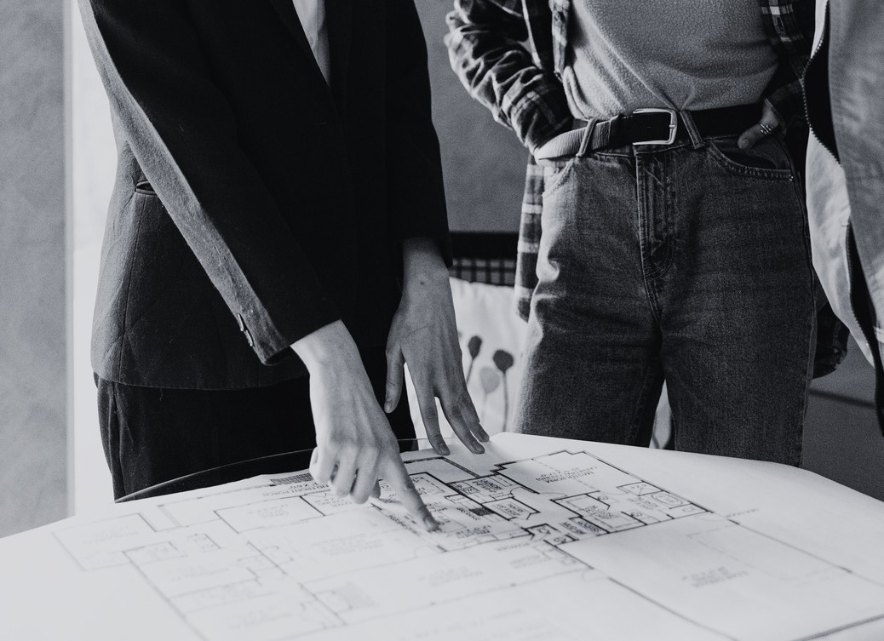
  - Water Tap Required
Type: □ Standard □ Garden Tap □ Nozzle Tap
  - Drain Position:
  - Re-routing Required: □ Yes □ No

Greenery / Planters
  - Pots Required (Small / Medium / Large)


  - Drip Irrigation
  - Artificial Turf
  - Vertical Garden Material:

Notes:
Date:

Safety


  - Child Safety Grill
  - Bird Net
  - Anti-Slip Coating
  - Check Railing Height Compliance

Page 47

buildschoolbyeka.com

Notes

buildschoolbyeka.com
buildschoolbyeka.com

Page 48

Next Steps

Follow us

Social
@buildschoolbyeka

@ekastudiobysana

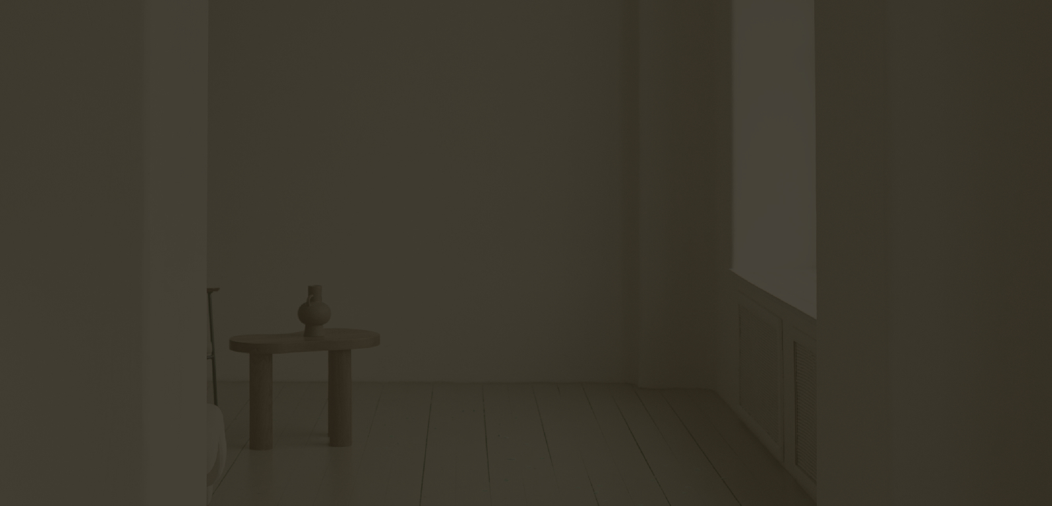

Tag us in your brand reveals and updates on socials so we can support you!

The ultimate scope sheet Page 49

